Description of Test | Expected Output | Actual Output | Screenshot | Test pass  /fail
Fragment Loading | Fragments appear simultaneously | Both fragments appeared | 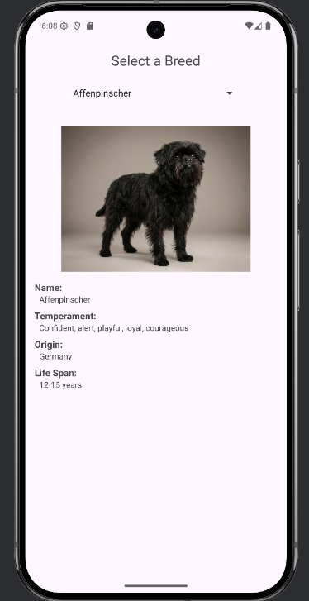 | P
Initial API Fetch | Spinner populates with breeds | Breeds appeared | 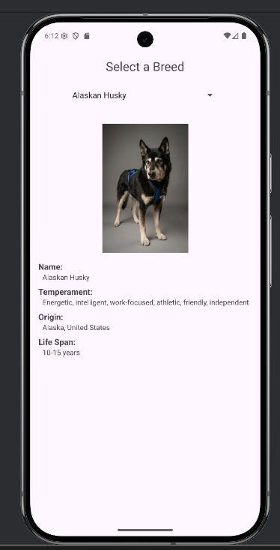 | P
Breed Select | API call fetches breed details and images |  | 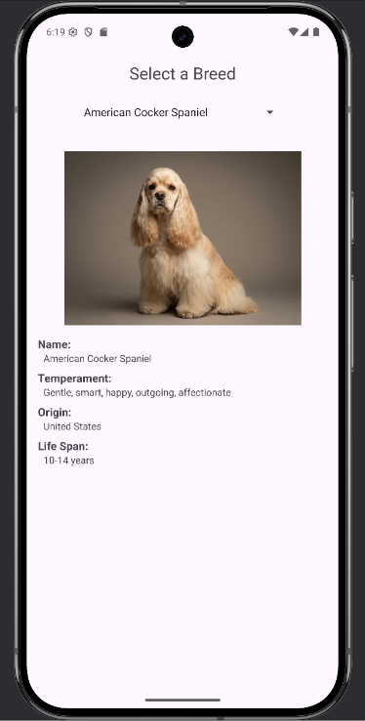 | P
Subsequent Selection | UI updates with new dog data |  |  | P
ScrollView | ScrollView allows vertical scrolling. |  | 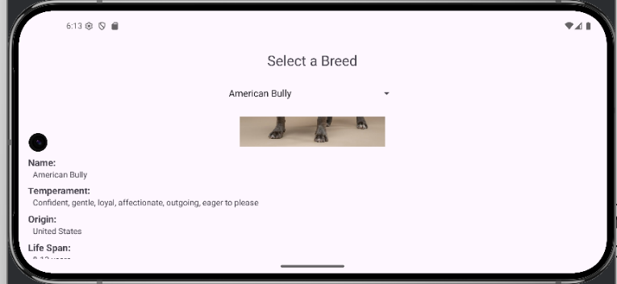 | P
Screen rotate | Data persists without crash | App rotates and does not crash | 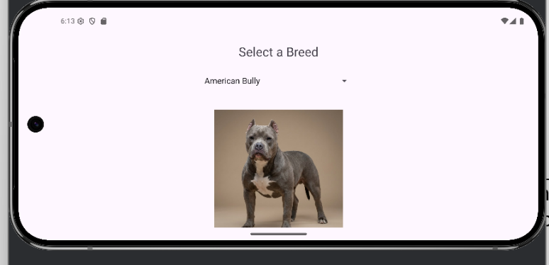 | P

